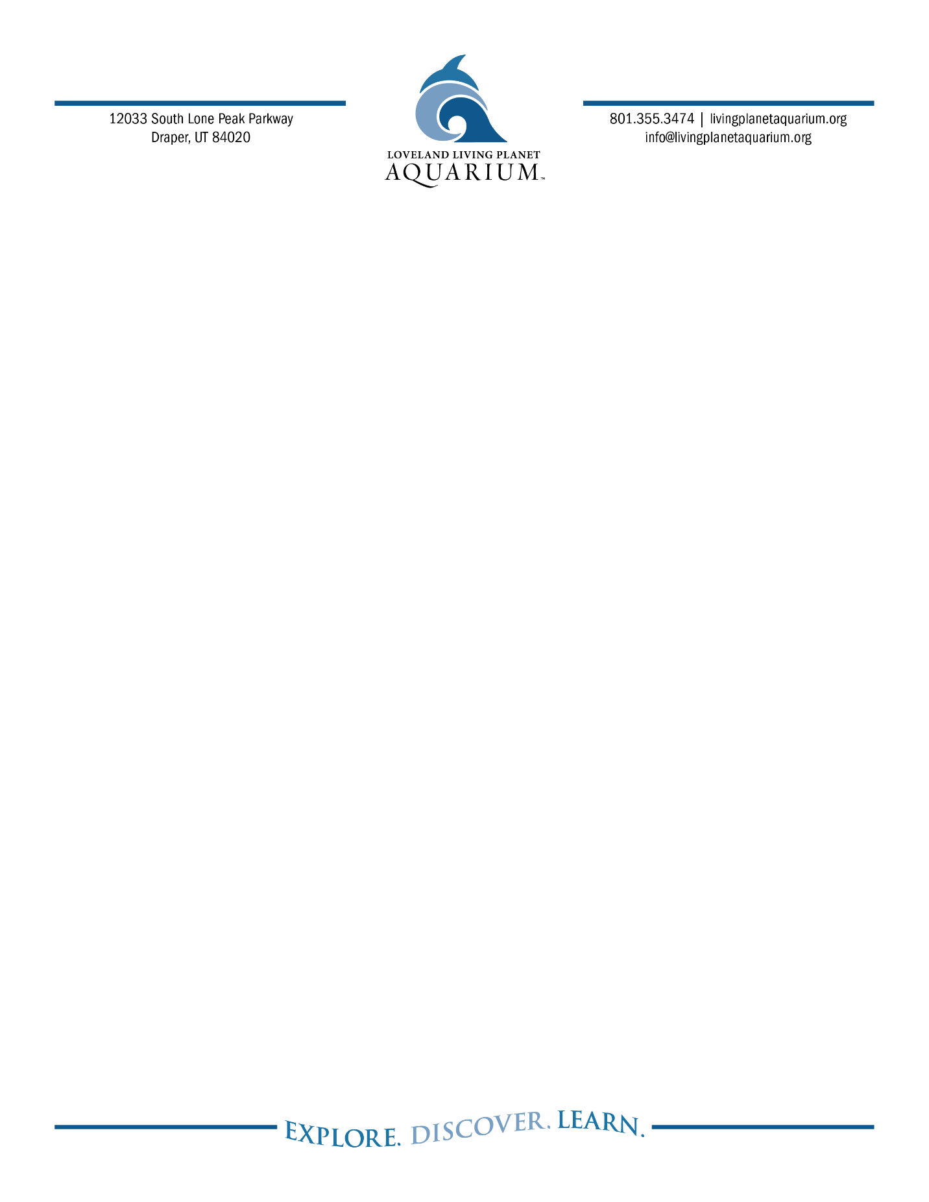
FOR IMMEDIATE RELEASE

Ashley Garcia, Marketing and PR Specialist
719.424.9500
ashley.g@livingplanetaquarium.org

Summer Camps 2025
DRAPER, Utah (February 5, 2025) And the winner of Super Bowl LIX will be… the Kansas City Chiefs! At least according to Honey and Simon, two Asian small-clawed otters at Loveland Living Planet Aquarium.
The pair were presented with two frozen footballs, each adorned with the team names of the two big game competitors. At first, the otters seemed a bit indecisive, briefly investigating both footballs. But, it was Honey who made the tackle on the Chiefs football, declaring her prediction of the winner.
Super Bowl predictions are a long-time tradition at Loveland Living Planet Aquarium and are enjoyable by not only spectators but offer unique enrichment for the animals. Rebecca Westover, Curator of Birds and Mammals, said, “This not only helps them interact more actively with their environment, but it also stimulates their problem-solving skills, promoting overall mental and physical enrichment.”
The Aquarium has four Asian small-clawed otters: Honey and Simon, and Kai and Emmie. Both pairs are part of the Association of Zoos and Aquariums’s Species Survival Plan program aimed at increasing genetic diversity and ensuring the survival of endangered and vulnerable species.
About Asian small-clawed otters:
Asian small-clawed otters are the world’s smallest otters, ranging in size from 4-8 pounds. They can be found in Southern India, Southern China, and parts of Southeast Asia in freshwater wetlands and mangrove swamps at higher elevations. They are currently listed as “vulnerable” by the IUCN Redlist of Threatened Species.
B-ROLL ATTACHED:
https://drive.google.com/file/d/1S7mcPbIeoZL5cYPRs9R9aTLXb8XfsMS_/view?usp=drive_link

About Loveland Living Planet Aquarium
Loveland Living Planet Aquarium is a 501(c)(3) nonprofit organization with a mission to inspire people to Explore, Discover, and Learn about Earth’s diverse ecosystems. A world-class facility, the Aquarium provides learning opportunities at all levels, interests, and ages. Since opening in Draper in March 2014, the Aquarium has welcomed over nine million guests. In addition, the Aquarium provides 82,000 student experiences by visiting every public elementary school in the state each year. Loveland Living Planet Aquarium is accredited by the Association of Zoos and Aquariums (AZA).
livingplanetaquarium.org ~ Facebook ~ Instagram ~ TikTok

