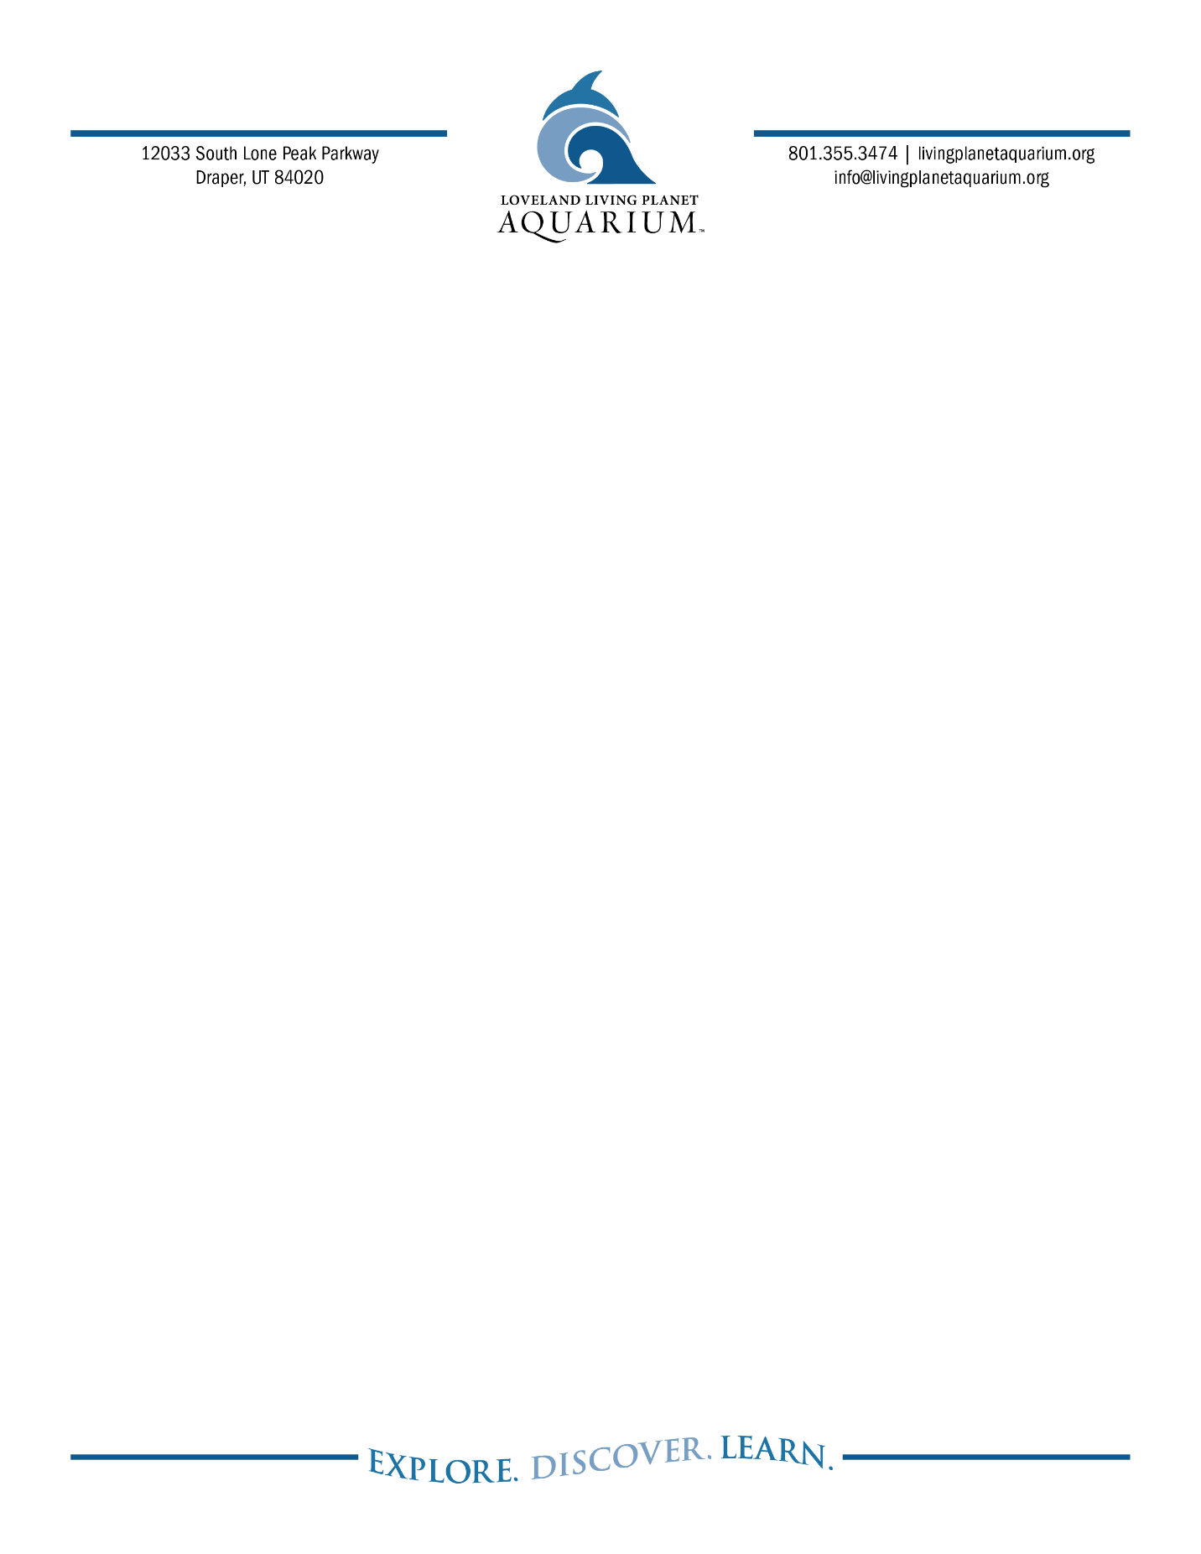
FOR IMMEDIATE RELEASE

Layne Pitcher, Vice President of Marketing and Operations
720.765.9406
Layne.p@livingplanetaquarium.org

Egg-cellent Eats and Underwater Treats
At Loveland Living Planet Aquarium’s First-Ever Spring Bunny Brunch
DRAPER, Utah (February 28, 2025) Calling brunch lovers everywhere! Loveland Living Planet Aquarium is hosting its first-ever Spring Bunny Brunch on Sunday, April 20, 2025. Bring the whole family for a morning of exquisite food, photos with the Spring Bunny, and full Aquarium access, all while taking in the only ocean view in Utah.
Spend an eggs-tra special morning with loved ones enjoying a sumptuous brunch featuring action stations, traditional favorites, and artfully crafted displays. The menu caters to a variety of tastes, ensuring a delightful experience for all attendees.
"We are absolutely thrilled to host our first-ever Spring Bunny Brunch!" said Events Specialist Jennifer Long. "This event is a wonderful opportunity for families to enjoy a delightful meal while immersing themselves in the wonders of our living planet, from the piranhas of the Amazon to the different sharks of the vast ocean.”
There are two seating options available to choose from, one at 10:30 am and one at 2 pm. Tickets include food, coffee, and soda, with alcoholic beverages available for purchase. Each ticket also grants full access to the entire Aquarium, allowing guests to explore and learn about Earth's diverse ecosystems.
Tickets are limited and can be found at livingplanetaquarium.org/spring-bunny-brunch/

B-ROLL ATTACHED:

About Loveland Living Planet Aquarium
Loveland Living Planet Aquarium is a 501(c)(3) nonprofit organization with a mission to inspire people to Explore, Discover, and Learn about Earth’s diverse ecosystems. A world-class facility, the Aquarium provides learning opportunities at all levels, interests, and ages. Since opening in Draper in March 2014, the Aquarium has welcomed over nine million guests. In addition, the Aquarium provides 82,000 student experiences by visiting every public elementary school in the state each year. Loveland Living Planet Aquarium is accredited by the Association of Zoos and Aquariums (AZA).
livingplanetaquarium.org ~ Facebook ~ Instagram ~ TikTok

