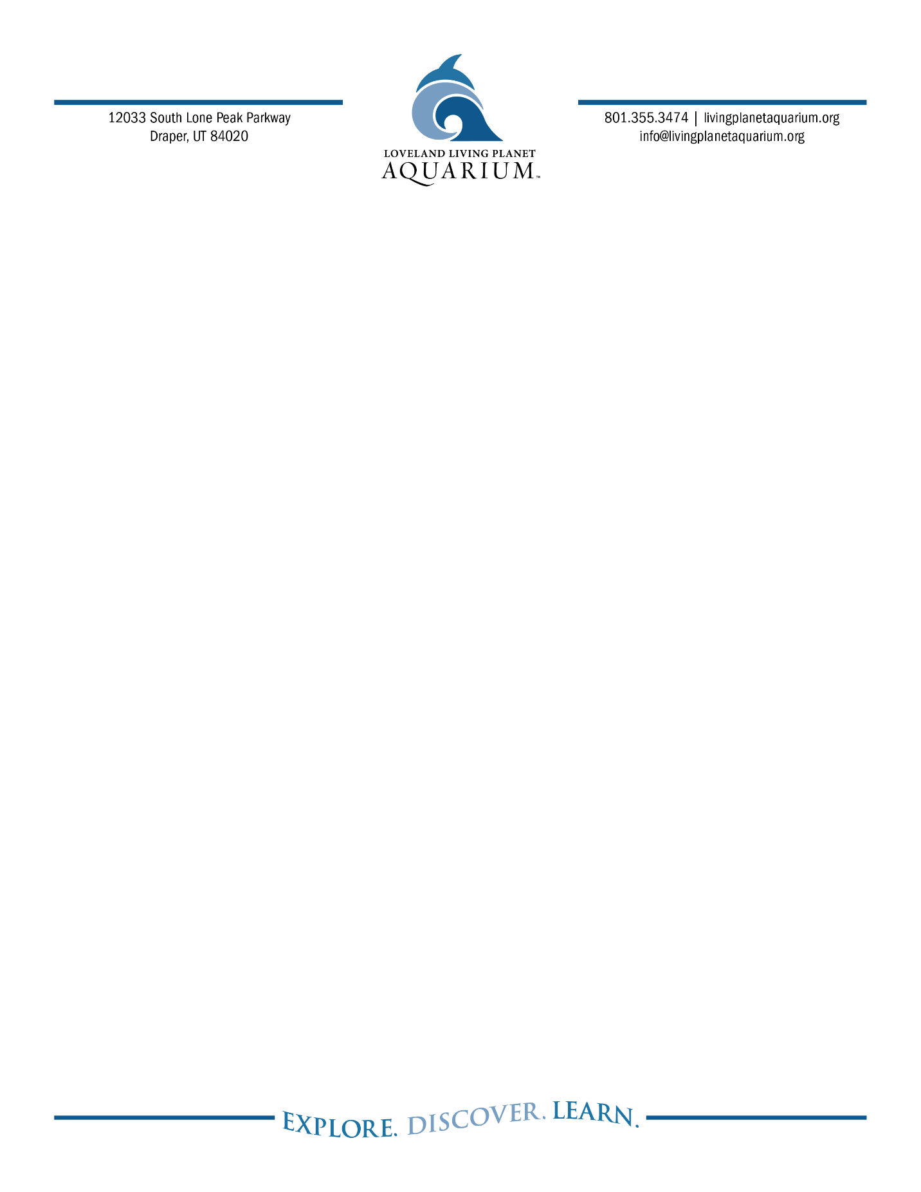
FOR IMMEDIATE RELEASE

Ashley Garcia, Marketing and PR Specialist
719.424.9500
ashley.g@livingplanetaquarium.org

Macaroni Penguins
DRAPER, Utah (February 6, 2025)
About macaroni penguins:
B-ROLL ATTACHED:

About Loveland Living Planet Aquarium
Loveland Living Planet Aquarium is a 501(c)(3) nonprofit organization with a mission to inspire people to Explore, Discover, and Learn about Earth’s diverse ecosystems. A world-class facility, the Aquarium provides learning opportunities at all levels, interests, and ages. Since opening in Draper in March 2014, the Aquarium has welcomed over nine million guests. In addition, the Aquarium provides 82,000 student experiences by visiting every public elementary school in the state each year. Loveland Living Planet Aquarium is accredited by the Association of Zoos and Aquariums (AZA).
livingplanetaquarium.org ~ Facebook ~ Instagram ~ TikTok

