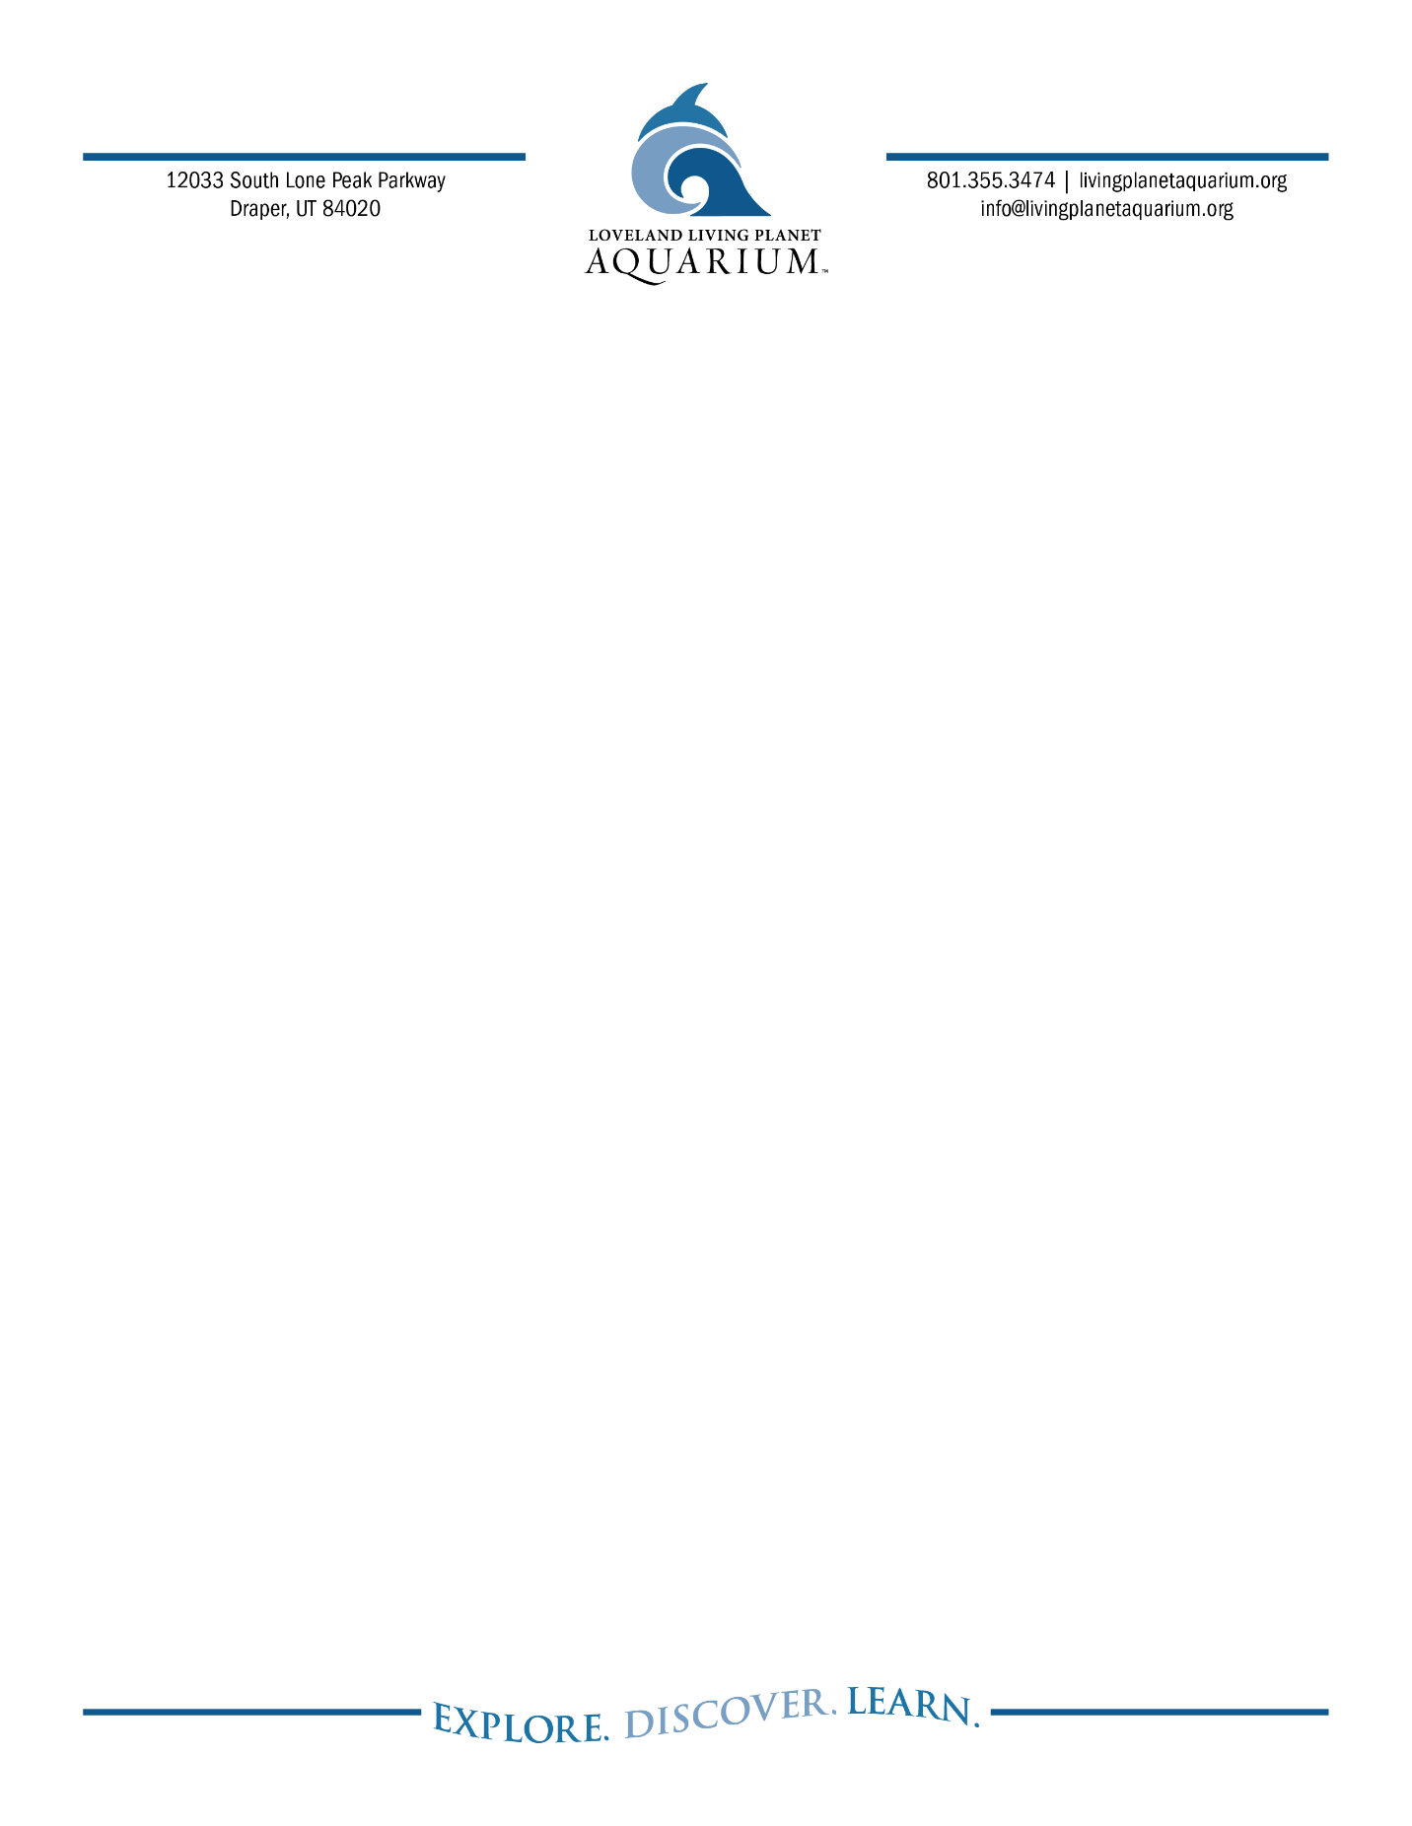
FOR IMMEDIATE RELEASE

Ashley Garcia, Marketing and PR Specialist
719.424.9500
ashley.g@livingplanetaquarium.org

Serving Your Penguin Educational Content Ice-Cold
Penguin Dating Series, Love on Thin Ice, is Back for Season Two
DRAPER, Utah (February 28, 2025) “Hey guys! We’re back! Did you miss us? Cause we missed you!” Love on Thin Ice, Loveland Living Planet Aquarium’s hit penguin dating series, is back for season two! The series saw record engagement last year after spilling the iced tea of penguin dating dynamics and educating about the natural mating behaviors of gentoo penguins.
From squabbles to mate stealing to changing preferences, love, and drama permeate the chilled air in Loveland Living Planet Aquarium’s Antarctica habitat, where 22 gentoo penguins have just started the 2025 breeding season, which lasts for approximately 3-4 months from February through May.

Dispelling the misconception that all penguins mate for life, Love on Thin Ice sheds light on the diverse mating behaviors observed within the species. While certain penguin species exhibit monogamous tendencies, such as pairing with a single mate for a specific breeding season, gentoo penguins demonstrate a more fluid approach to relationships. Research reveals that during the breeding season, females may have 1-3 partners, while males may have 1-2. Despite these multiple pairings, gentoo penguins often return to the same mate, with a remarkable 90% fidelity rate.

All episodes will be uploaded to TikTok and Instagram, so viewers stay up-to-date on what’s happening with their favorite penguins. Will long-time couple Coco and Gossamer stay faithful? Will previously single Ava or Loki find love this season? How will 2024 babies Bentley and Aurora shake up the colony dynamic? Could the penguins welcome additional newcomers? Tune in to find out!

2025 Season 2, Episode 1:
https://www.instagram.com/reel/DGoeIJioEGL/?utm_source=ig_web_copy_link

About Loveland Living Planet Aquarium
Loveland Living Planet Aquarium is a 501(c)(3) nonprofit organization with a mission to inspire people to Explore, Discover, and Learn about Earth’s diverse ecosystems. A world-class facility, the Aquarium provides learning opportunities at all levels, interests, and ages. Since opening in Draper in March 2014, the Aquarium has welcomed over nine million guests. In addition, the Aquarium provides 82,000 student experiences by visiting every public elementary school in the state each year. Loveland Living Planet Aquarium is accredited by the Association of Zoos and Aquariums (AZA).
livingplanetaquarium.org ~ Facebook ~ Instagram ~ TikTok

